

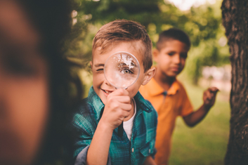

Resource Book

Supporting Autistic Children

Starting Primary School

Contents

Page
Introduction and useful resources list 3
School readiness 5
School readiness checklist 6-19
Sample School passport 20-47
- Overview
- Sample Passport
- Editable passport pack

Pencil grip ideas 49
Scissor skills ideas 52
How to use visuals 54
Dressing 57
Hand washing 59
Toileting 60
Break card 61
Finish/Change and Wait visuals 62
Using calendars 67
Turn taking 68
Visual on voice volume 70
Sample chase social story 71
Choice making 72
Social story: using fidgets in school 74

Introduction

The transition to school is a key event in a child’s life. It is also a major event in the lives of their parents. Autistic children are considered to be vulnerable in the transition process because of their differences in social communication and social interaction and difficulties processing change. This document was put together to help prepare children for the start of primary school. It contains a School Readiness Checklist, sample Pupil Passports and a Transition Workbook for the child. The links below will take you to information and resources that will help you to think about how you can prepare for the transition to school.

Note re. terminology: In this document we use identity first language ‘autistic person’, as the majority of autistic people prefer this.

Starting School: Guidelines for Parents / Guardians of Children with Special Educational Needs (National Council for Special Education, 2016)
http://www.pdst.ie/sites/default/files/1-NCSE-Starting-School-Guidelines-final-web-27.01.16.pdf

Starting school (Citizens Information) http://www.citizensinformation.ie/en/education/primary_and_post_primary_education/going_to_primary_school/primary_education_life_event.html

School Handbook for Parents (Autism Spectrum Information Advice and Meeting Point)
https://asiam.ie/wp-content/uploads/2014/08/ASIAM_Parents.pdf

Autism Education Trust (AET): this links to a document that has good questions for you to ask your potential school:
http://www.aettraininghubs.org.uk/wp-content/uploads/2014/09/what_to_guide_upload.pdf

The AET has a transition toolkit for helping children with ASD make transitions:
www.autismeducationtrust.org.uk/~/media/AET/Assets/.../Transition%20Toolkit.ashx

Tips for parents to support children moving from preschool to primary school: https://www.education.ie/en/Schools-Colleges/Services/National-Educational-Psychological-Service-NEPS-/guidance-transitioning-pre-school-to-primary-school.pdf

Your Child in the Primary School: TIPS FOR PARENTS (Irish National Teachers Organisation, 2017 http://www.into.ie/ROI/Publications/TipsforParents/2017_Tips_Eng.pdf
National Council for Curriculum and Assessment: Activities to support a child’s transition from preschool to primary school: https://ncca.ie/media/3755/suggested-transition-activities-for-preschools.pdf

Aistear Tipsheet: Suggested Activities for Pre-Schools to Support Positive Transitions to School underpinned by Aistear.
https://www.ncca.ie/media/3755/suggested-transition-activities-for-preschools.pdf

‘Ambitions for Transitions: A Guide to Support Every Child’s Progression from Early Years Services to Primary School’ – is an excellent resource pack that includes suggestions and resources for the family, pre-schools and primary schools in Ireland
https://www.paulpartnership.ie/wp-content/uploads/2018/03/Transition-Report-ABC-Start-Right-Web-.pdf

Supporting Students with Special Educational Needs to make Successful Transitions’ – is a guide written by the National Council for Special Education and contains Practical Transition Guidelines for Pre-Schools and Schools
https://www.sess.ie/sites/default/files/inline-files/5-NCSE-2016-Supporting-Students-final-web-27.01.16.pdf

The Autism Service (South Lee) has the following link which details how we can create an environment that supports autistic children. This can be made available to school staff: https://southleeasd.files.wordpress.com/

School readiness



All children starting school will have different strengths, skills and abilities and all will need help with some things. Teachers understand that children starting will be at varying levels of independence and will make allowances for this. There is a hope that children will be able to manage their own bags and coats, lunch and toileting. Children may be expected to sit at their desks for parts of the day and start to follow the general class routine within a reasonable length of time. Children may be expected to have a basic level of skill in tasks such as colouring.

Autistic children can be delayed in achieving some of these skills and may need extra time or supports to carry out routine daily activities. Some children are granted access to special needs assistants (SNAs) on the basis that they have significant care and safety needs. Giving information about your child’s strengths and needs will help the new school prepare for a successful start.

To help you gather information you can complete the School Readiness Checklist below. Other people involved in your child’s care can help too. Staff in preschool or home tutors might be able to give information on how your child behaves in different settings.

School Readiness Checklist


Child’s name: _____________________ Person(s) completing the checklist: ___________________________

Instructions: we recommend that you complete this checklist with your preschool staff.

Purpose of the checklist: to outline your child’s current and emerging skills. It can be used to:
  - Inform areas/skills that you and the preschool staff can support before September
  - Help the primary school understand your child’s strengths and needs and what supports work for them. This will help them plan for your child’s needs to ensure they meet their social and academic potential.

Please describe your child’s strengths:

Please describe your child’s likes and dislikes:

Your child’s strengths and areas for support: | Yes | No | Emerging | Comments
- Motor skills at the table
Does the child play with puzzles? How many pieces can they do?
Does the child play with beads, blocks or play dough?
Does the child show a hand preference or do they swap hands while drawing and colouring?
Is the child developing a mature pencil grip, e.g. holding the pencil between their thumb, pointer finger and middle finger? The child may also use their fourth finger to stabilise the pencil.
Does the child participate in colouring/drawing tasks? How long will they stay seated for?
Can the child use a scissors to cut a piece of paper in half?
- Motor skills during play and sport
Can the child independently use the stairs?
Can the child jump?
Can the child throw and catch a large ball?
Does the child enjoy playground equipment?
Are the following skills present? | Yes | No | Emerging | Comments
2) Self-Care
Can the child eat with a spoon or fork?
Can the child open containers and packets e.g. Lunch box?
Can the child drink from an open cup?
Can they drink from a straw?
Can they wash and dry their hands? Can the child turn taps on and off?
Can the child independently take their shoes off and put them back on?
Is the child independent in using the toilet?
Do they know when they need to go & how to ask to go?
Can they clean and dress themselves after using the toilet.
Do they need schedules to support them with this task?
Can the child identify their own belongings, e.g. a coat, bag, lunchbox?
Can the child put on and take off their coat independently?
 | Yes | No | Emerging | Comments
- Communication Skills
(communication includes using: words, lámh sign, gesture, showing, giving, body movements pointing, vocalisations, visuals, using a low or high tech device)
Can the child ask for help?
How? If not what do they do instead?
Can the child communicate you they need to go to the toilet?
Can the child communicate if they are feeling unwell or hurt?
How?
Can the child communicate that they want a break?
How?
Can the child communicate that they want to finish an activity?
How?
Can the child communicate when they are hungry/ thirsty?
(Not necessarily using a verbal message)
Is the child able to make choices? (from how many options)
With what support?
Can they communicate their likes/dislikes?
How?
 | Yes | No | Emerging | Comments
4) Emotional Awareness and Regulation
Does your child know what they are feeling when they are happy / sad / angry / worried/ tired ?

How do they express their feelings?

Do their reactions ever seem over the top at times? Please describe

What do you do to help your child to calm down?

Does the child understand other people’s body language (facial expressions, gestures, intonation etc.)?
 | Yes | No | Emerging | Comments
5) Social interaction
Is the child interested in interacting with their same age peers?

Is the child able to take turns
(i) In a back and forth exchange with an adult that involves the adult imitating the child’s action?
(ii) During a simple turn taking game with an adult?
(iii) During a game with peers?
What supports them to do this? e.g. turn taking chart
How does the child react when things don’t go their own way:
Are they able to negotiate with others?
Can they cope with losing in games?
Does the child offer comfort to others?
Does the child seek comfort when upset?
 | Yes | No | Emerging | Comments
6) Play
Does the child play with a range of toys? Please describe:
What kind of play does the child enjoy? e.g. rough and tumble / physical play, construction play, water play, creative play, dressing up, group games, pretend play,? etc. Please describe:
Does the child need adult support when playing?

Will the child allow others to join in with them in play?

 | Yes | No | Emerging | Comments
7) Routines & Stereotyped behaviours
Does the child move easily from one activity to another?
Do they need to fully complete a task before starting a new one?
What supports them to transition?
Can the child cope with changes to routines?
Do they have any routines that they need to follow?
8) Environmental Supports
Does the child follow schedules, if so how are they presented to them (what kind of symbols, where are they located etc.?)
Is the child using/familiar with a ‘wait, change or finish’ sign/symbol. If so when are they used?
9) Sensory Needs
Is the child very sensitive to any sensations in their environment, e.g. noise or textures?
Does the child seek out sensory input to a degree that it impacts significantly upon their daily activities? E.g. mouthing objects, high level of movement or touching, etc.
 | Yes | No | Emerging | Comments
Does the child need breaks in a quiet environment or time by themselves without other children?
Does the child need breaks that provide a lot of movement input?
Does the child have any special equipment or toys that help them to feel regulated? E.g. fidget toys or chewing toys.
10) Safety
Do you have any concerns about your child’s safety? Please describe:

Environment and Communication Partners Checklist | Yes | No | Emerging | Comments
Supporting Communication
*A communication partner is anyone interacting with the child
Understanding
Are we as communication partners giving the child at least 10 seconds to process what has been said before repeating or saying something else?
Are we pairing verbal language with visual supports, lámh signs or gestures?
Do we try to get the child’s attention before talking to them?
If a child doesn’t understand an instruction how do we adapt our communication to support them?
Expression
Are we creating opportunities for communication across the day especially during routine activities?
Are we interpreting the child’s messages?
If there was an unconventional behaviour are we modelling a more universally understood way of communicating this?
Are we modelling appropriate language in different situations for the child?
Are we expanding on the child’s messages by adding a word or sign?
Are we using grammatically correct language that is appropriate for the child’s level of understanding?
Supporting Social Interaction
Are we using a balance of questions and comments?
Is there a balance between directing the child and following his/her lead?
Are we getting down to the child’s level when interacting with them?
Are we responsive to the child’s communication attempt (which may not be a verbal message)?
If the child has language difficulties are they given opportunities to participate in limited language based activities?
Are we supporting the child to participate in peer interactions? (e.g. incorporating interests, teaching phrases, pre teaching game/activities, using visual supports, using social stories).
Are we supporting peers to interact with their autistic classmate?
Supporting Emotional Regulation
Are we talking about how they are feeling in the environment? (PALMing: Pause Attune Label Model/Modify
Are we identifying and labelling how children are feeling? E.g. “you’re sad”
Are we discussing people’s preferences and validating them?
Other
Are we incorporating the child’s special interest in any daily activities?
Are we supporting children during transitions?
How?

Pupil Passports

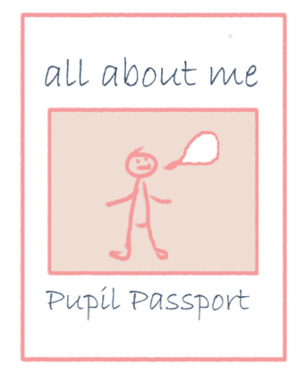
The pupil passport can be a very useful tool to use to help to support a child’s transition into their new school. The passport should provide the new staff working with the child with key information around the child’s strengths and needs across a broad range of areas. This may include:

- Strengths and interests
- Important people in their lives
- Their communication skills (verbal & nonverbal)
- Their social interaction skills (with adults and peers)
- Their play and imagination
- Their sensory preferences
- Their academic ability
- Motivators
- Ways in which the child can be supported

The passports are written from the child’s point of view, using clear and simple language and including examples where necessary. E.g. If you were stating from the child’s point of view that they find change difficult then you may include an example of the kinds of visual supports that are being used to support this.



Below are two sample reports which can be used as templates for sharing important information about your child to school. You can use the information collated in the School Readiness Checklist to help. Remember the pupil passport should be individualized to a child’s specific needs.
Name of Child: Completed by:
Date of Birth:

Introduction- My name is (child’s name)______________________

The most important things you need to know about me:

Medical Information:

Important people (e.g. Family, friends)

I really enjoy:
I am good at:
I am learning how to:
I like to go to:
I like to eat:
I like to drink:

I show I am happy by: (e.g. telling you, smiling, dancing, moving):

These are things that I dislike:
These are things that may upset or frighten me:
I show I am worried or sad by saying/doing this:
When I am worried or sad, I need to:
(e.g. be alone, be with others, go to a quiet place)
These are ways you can help me to feel calm and safe if I am upset or
unhappy:

I indicate that I am feeling unwell by:
I indicate that I need to go to the toilet by:
I indicate that I am hungry/thirsty by:

Strategies:
These are things you can do to help me to work as best as I can:

Any other things you may want to include:

Sample 2
My Name
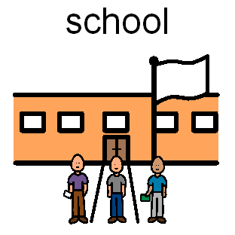
My name is XXXX. I am 5 years old. I am starting primary school in September. This is some information for my new teachers and helpers. It will tell them about the things that I am good at and things that I have more difficulty with. There are also some tips on ways to help me to learn in my new classroom.
Important people in my life 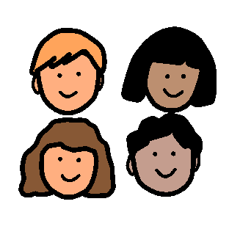

My Man

My Dad
My brother
My Nan

Things that I can do
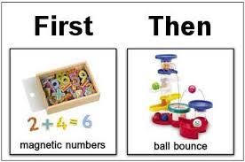
- I am good at following visual schedules. These are useful to help me to know what is happening during the school day which helps me feel calm. I need to have my name or picture on my schedule so that I know that it is mine as I am not consistent at reading my name yet. The schedules that help me the best are those with a line drawing picture and the written word on top. The same symbols need to be used consistently. When my reading gets better I might? be able to have a written schedule.

- I can play simple turn taking games with at least 2 other children once I clearly know what the rules of the game are. I will say 'it's my turn' when I am to take a turn and I will comment on what is happening. I can do this better when a turn taking rota is used as sometimes I forget when it is my turn.

- Sometimes I find it hard to wait for my turn. A 'wait' card and turn taking rota with people's pictures on it helps me.


- I find it easier to change activities when I know in advance that what I am doing is nearly finished. For example, five minutes before a task is ending tell me that the end is approaching and then remind me again when I have only one minute left. Then tell me that the activity is finished.
- I like doing my work when I know that there is a clear beginning, middle and end to the tasks/activities so I know what is exected of me and how long more I need to attend for I like it when my tasks are visually based. Visual learning is one of my strengths as I find words on their own difficult to understand.

- I understand time and activities better when the concepts of ‘first and then’ are used. For example ‘FIRST work, THEN play’. Concepts such as ‘soon’ or in ‘5 minutes’ are difficult for me to understand.

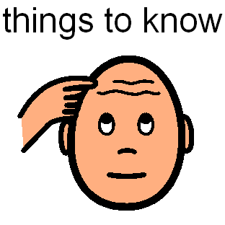
- I am good at working hard and I enjoy doing well. I like to answer adult’s questions and I am getting very good at spontaneously sharing information with other people. Visual aids can be used to support me even more with this. I like to comment on things that are happening around me or on things that I am doing.

Things you should know about me
- I am good at greeting people and my eye contact is improving when I do this. I may need to be prompted of what to say. Sometimes I will start talking about something that I am thinking about, even though my thoughts are not relevant to what is currently happening. I may use it as a means to start a conversation with someone. I really like talking about (insert here)______ and it is important that I am given time to talk about it with others.

- I am good at listening to others talk in a group and I can ask my friends questions and comment on what they have said.

- I may get restless waiting for my turn during group work. This may due to my difficulty in understanding the demands of the activity and knowing what is required from me. I can be supported using a visual to know when my turn is coming

- My behaviour is sometimes own agenda in nature. This means that it is tricky for me to follow what other people want me to do as I want to do my own thing. Visual supports really help me with this, for example I am good at using a ‘wait’ and ‘change’ card. It is important that I have time in my schedule where I can do things I want to do. If I have difficulty following the plan please remind me that I can do the thing I want to do later. I am much more interested in a task when my interests are included e.g. _____ and when my sensory preferences are included e.g. ___________

wait

- I need to have short varied tasks in order to maintain my attention.

- Sometimes I may appear not to be listening when I actually am. At times I need to be reminded to listen and to ask for clarification when I have not heard what other people said. Flapping my hands/rocking back and forth etc can help me to listen and I should be allowed to do these things and not told to stop?

- I need ‘time out’ during the day. Breaks need to be scheduled during the day for me andit helps me if I can see this on my schedule This helps me with my behaviour. During this time I would love if I could get some of my sensory needs met. A ‘break’ card can be used on my schedule and also placed on my desk as a visual cue to let me know that a break is coming up or to prompt me to ask for a break. As well as scheduled breaks in the day sometimes I need extra breaks especially if I have not slept well the night before. I need people around me tp recognize signs that I need an unscheduled break.

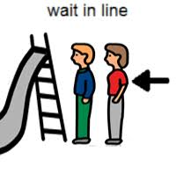
- I am good at playing alongside my peers. Sometimes my play is solitary and I will need an adult to support me in joining in with my friends. Sometimes I find it difficult to learn other things to do with the toys and negotiate play routines with my peers. I need to practice with adults first and gradually have more adults and peers join in my game. Unstructured free play is very difficult since I am not sure what to do and the rules may change each time I play. It helps me if you can teach me different sentences that I can say when I am playing. I can learn or copy those sentences and may choose to use them when I play with my friends.

- At times I may find it hard to negotiate with other children. For example I may find it tricky if I want to do something different to what my friends want to do. I will need an adult to help me with this. Sometimes I find it difficult to think of other people’s feelings and to consider what they might like to do.

- I will sometimes repeat aloud what people have said to me in order to help me to remember and understand.

- My interpretation of language and thinking about the world around me is very ‘black and white’. This can lead to me being quite rigid in my thinking, which makes it harder for me to accept changes. At times I can have a literal interpretation of language.
Things that upset me 
- Sometimes I find it hard to manage my emotions and I might get upset when things don’t go the way that I want them to. I might be physical towards other children and I still need to learn to know what to say when I am upset.

- I don’t like it when people get too close to me or when I am at my desk and my friends stuff gets too close to mine. I might need to be prompted of what to say when this happens.

- I am a perfectionist!! I like for things to look or be a certain way and I find it hard to manage when they don’t.

- I am very good at colouring and using a scissors.

Ways to help me calm and be comforted

Places I like to go 

- I like to go outdoors, to the park, swimming, Granny or Gran’s houses.
- Things I like to eat and drink 
Ways you can help me in the classroom 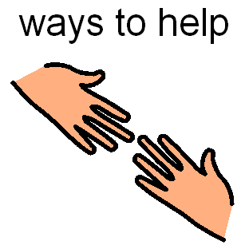
- It is essential that I have frequent and scheduled sensory movement breaks throughout the day and unscheduled breaks if needed

- Give me at least 10 seconds to process language. After that if you have to repeat yourself, please say the exact same thing again as this helps me instead of saying things differently

I like it when there is consistency and routines during the day both at home and at school When things are predicatable I do not have to worry about changes and whay these entail.
- I like the routine of school and I like to know in advance where we are going and what we will be doing. I like to know who will collect me from school. Visual schedules are ncessary to help me to know what is happening during the school day. I can have my picture and name on my schedule so that I know that it is mine. The schedules that would help me the best are those with a line drawing picture and the written word on top. The same symbols need to be used consistently. When my reading gets better I will be able to have a written schedule. I really like to know the plan of what is going to happen. I could be taught how to manage changes to my routine using a change card on my schedule (there are instructions on teaching about change at the end of this document).
break
- Visual aids (using principles of the T.E.A.C.C.H approach) help me enormously. This includes the use of visual schedules outlining the day’s activities e.g. Circle time, work at table, break time, play time etc. It helps me when my photograph is used on top of the schedule.

- Behaviour charts (e.g. reward or smiley face chart) and rota charts also help me. It helps me to know what specific reward I am working towards such as bubbles, trampoline etc.

- Social stories (Refer to Carol Gray) are These stories are written in the first person ‘I’ and explain what I should do. Very simple language and symbols are used in these stories that are then read to me. Social stories can also be used to prepare me for any upcoming changes e.g. a school tour, a no uniform day etc.

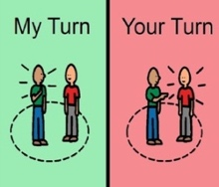
- I am learning to take turns. I need to be supported to use my words to tell my peers what I want. You could model the appropriate language for me so I know what to say. Using a turn-taking rota will help me to know whose turn it is and when it will be my turn. 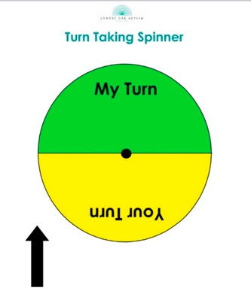this one is nice

- I am learning to share with others but may need reminding.

- I like it when the environment is visually structured. For example, clearly knowing where is the work area, play area etc. It is also useful to have my name/photo on my desk and schedules or on my chair. This helps me to be as independent as possible.

- I may need support in the yard to play with my peers- having an adult set up structured games such as chasing, Mr Wolf etc. will help me play with my friends.

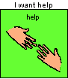
- Please encourage me to ask for help or seek clarification when unsure in order to promote my independence. Even though I may sit quietly this does not mean that I know what to do. I may look to my peers for help and to copy what they are doing.

- A 'home-school' journal should be used to have regular communication in both settings. This should reflect the things that I am doing well and the things I find tricky. News from my school day can also be included in my journal. I may find it difficult to share news from one situation to another. If my mummy has some information on what I have done in school they will then be able to help me to share my news with her.

- Choice Boards with my favorite activities help me to decide what to do during less structured times e.g. free time Sometimes I need direction, as I may not always spontaneously think of things to do.

- I need to be encouraged to do things by myself. Backward chaining (teaching me the last step of a task first) helps me be successful in learning new skills.

- Use of skill sheets, social stories, comic strip conversations and role-play assist me in learning the rules of games. I must practice with adults first and gradually have more adults and peers join in my game. Unstructured free play is very difficult since I am not sure what to do and the rules may change each time I play. I may need to have more structure provided. For example, holding a baton when playing chase to show that I am "on".

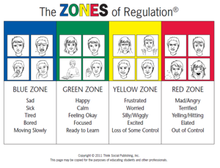
- I am still learning about my emotions and other people’s emotions. I can over-react to things at times and I can become angry and frustrated. Gently naming the feeling for me might help when I am experiencing it. The Zones of Regulation Program is a structured, visual way for me to learn about feelings and emotions in both myself and other people. I would like to have Zones chart made up with my favourite characters on it.

Hopefully this information will enable my new teachers to help me as much as possible. I know that I will be in a busy class but these simple strategies will make a big difference to me starting school.

I am really looking forward to starting my new school!!

Thank You


Transition Booklet

You can complete the attached booklet with your child, adding in as much detail as possible, using drawings and photographs where necessary.
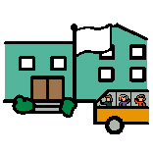

Going to School

Name: __________________

Insert picture

This is my new school. It is called

I will start my new school in September. I will usually go to school on

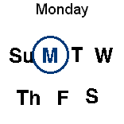

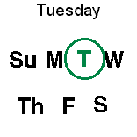

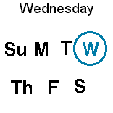

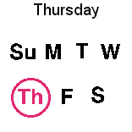

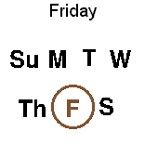

There is no school on

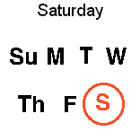

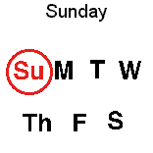

This is called the weekend.

I will usually go to school with
(Circle as appropriate or add in photographs/drawings of other people)

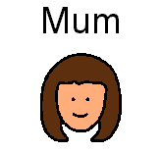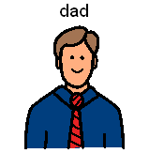

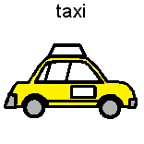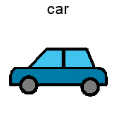

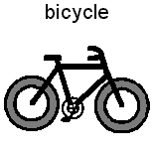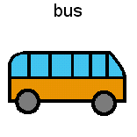

I will usually go to school by (circle as appropriate)

____________ with

___________________________ .



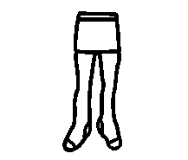



I will usually wear (circle and colour in as appropriate) ________________________________________________
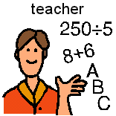

Here is my teacher.

His/Her name is _________________.

He/She will help me with my work.

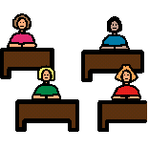

Here is my classroom.

I will sit on a chair at my desk.



Here is my helper.

Her name is ___________________.

She will help me with my work.



There are lots of children in my class.

They will be my new friends.

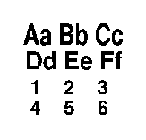
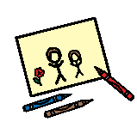

I will learn about letters and numbers.

I will colour and draw.

I will sometimes play.

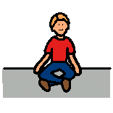

Sometimes I will sit at the table.

Sometimes I will sit on the floor.

My teacher will tell me where to sit



At lunch time I might eat

and I might drink ___________.

Mum or dad will get my lunch ready for me to bring to school.

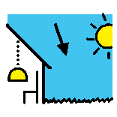

At break time I will usually go outside.

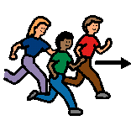I might play ________________.

When it is wet or too cold I might not go out at break time.

Instead I might stay in my classroom or go to the halla.

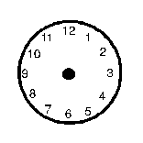 School usually starts at __________ .

School usually ends at____________.

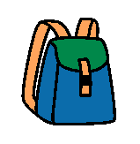

When school is finished I will try and put my books into my school bag.

An adult might help me with this.



When school finishes _______________ (insert name) will usually pick me up and bring me home.

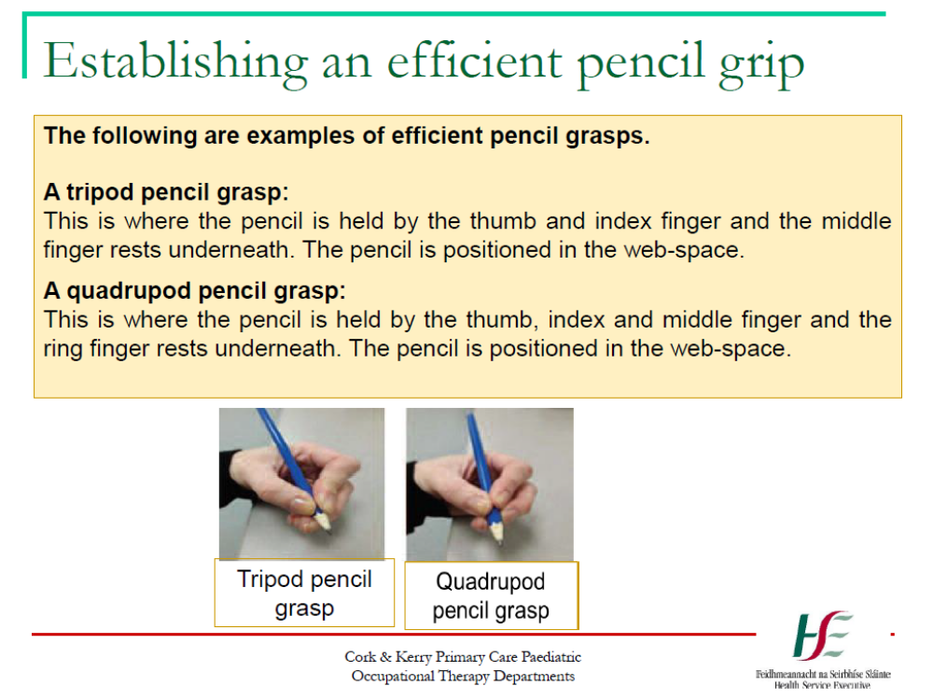

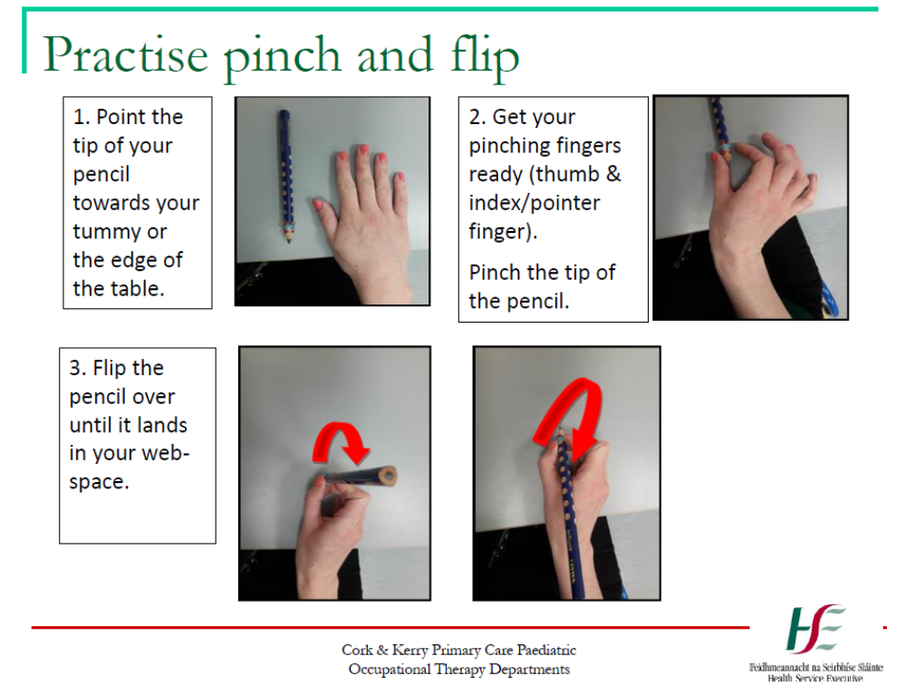

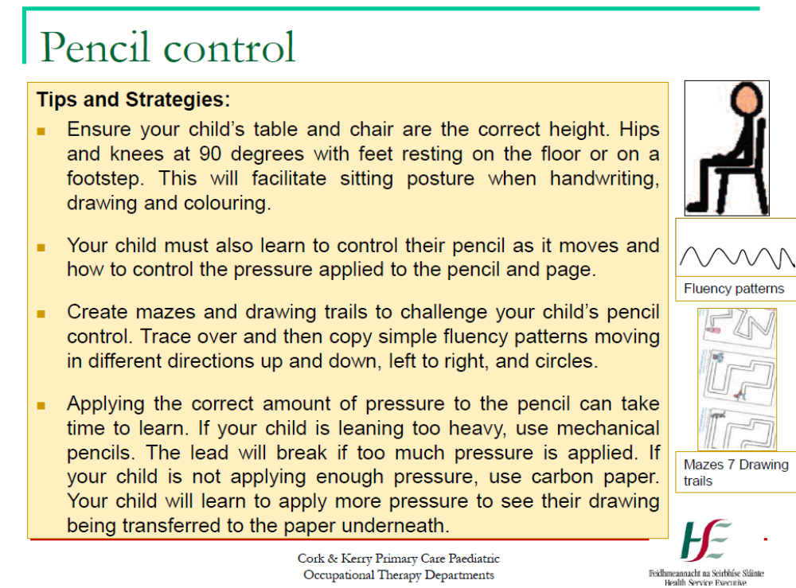

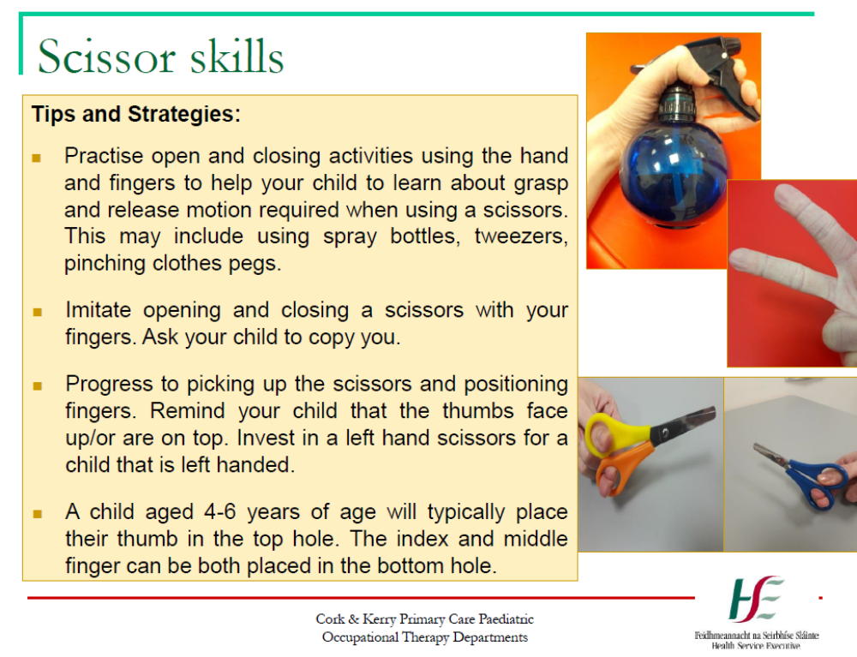

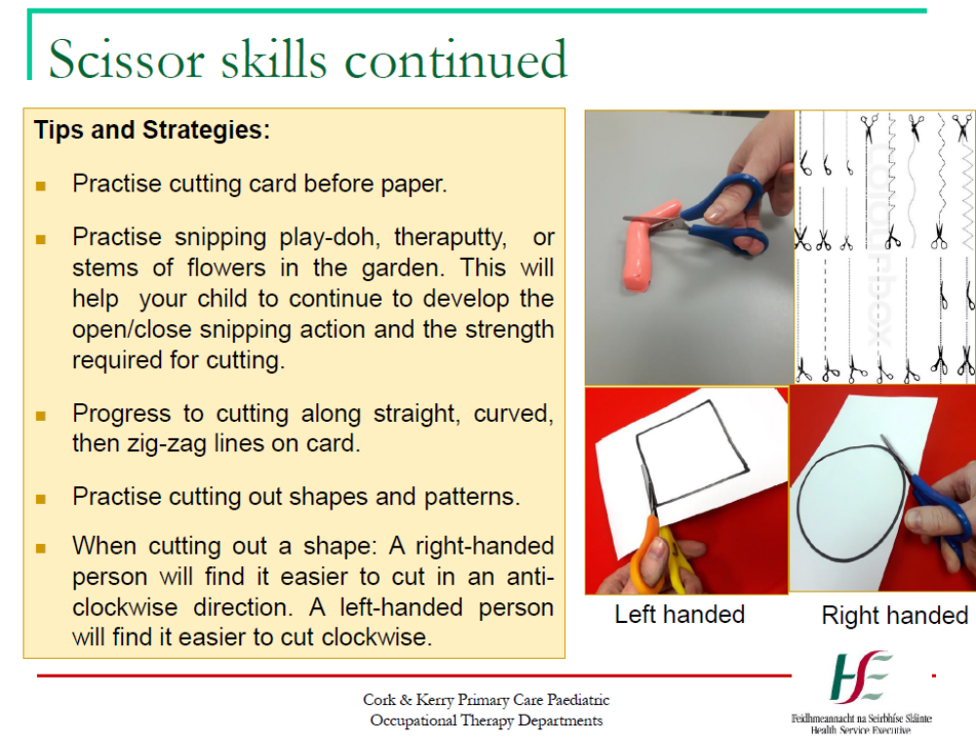

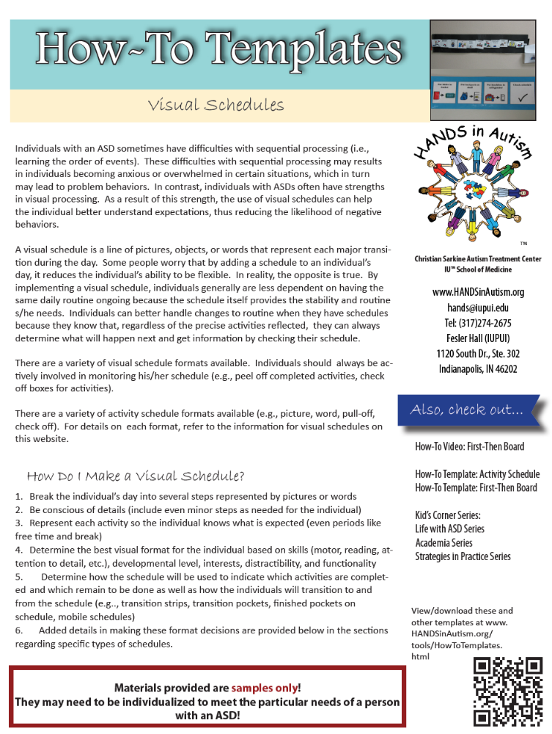

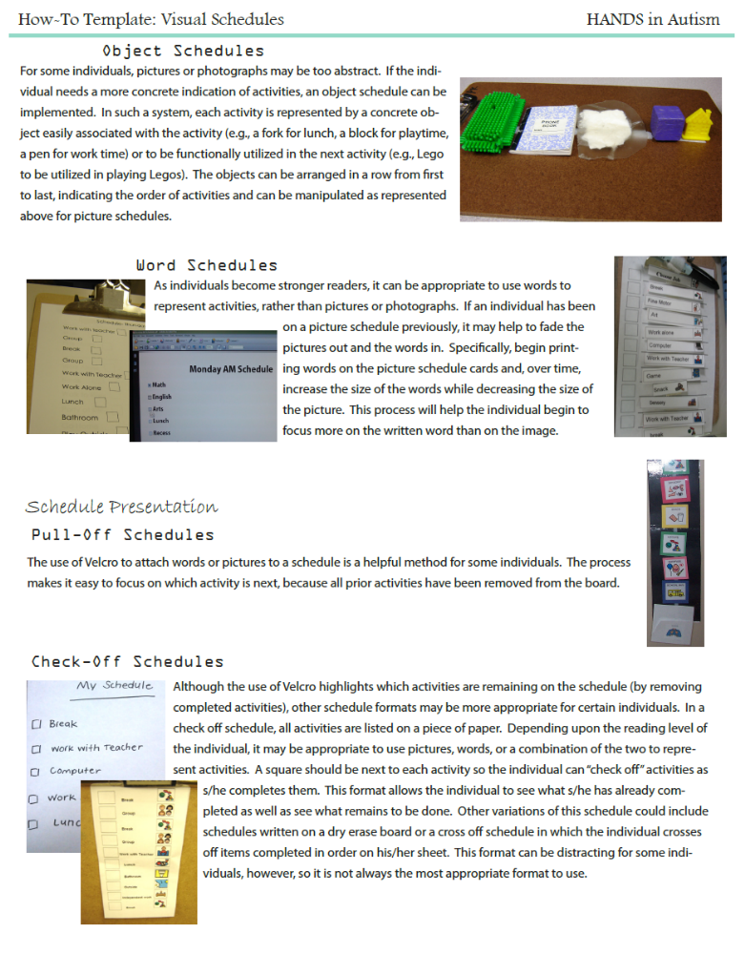

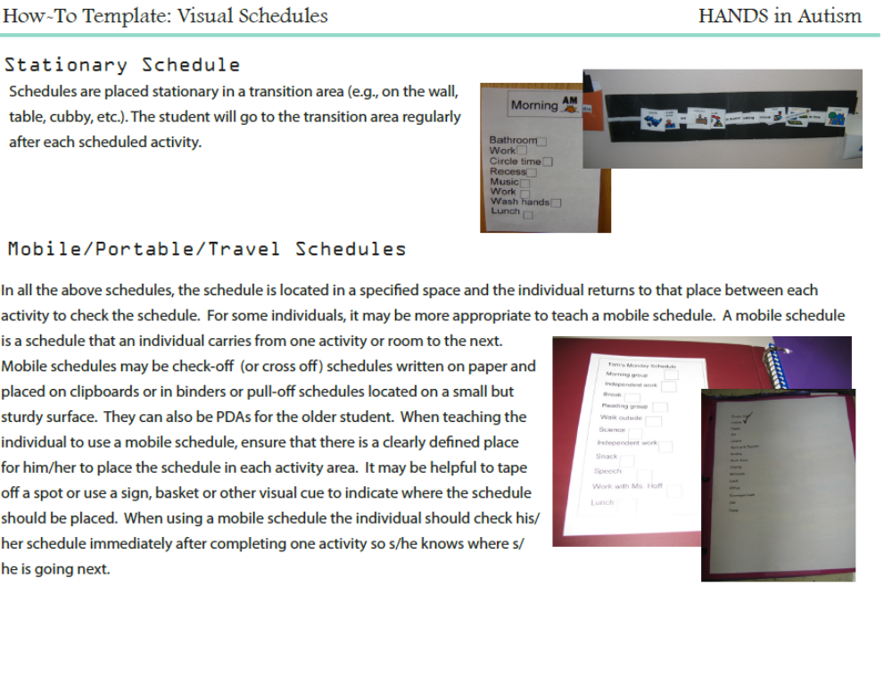

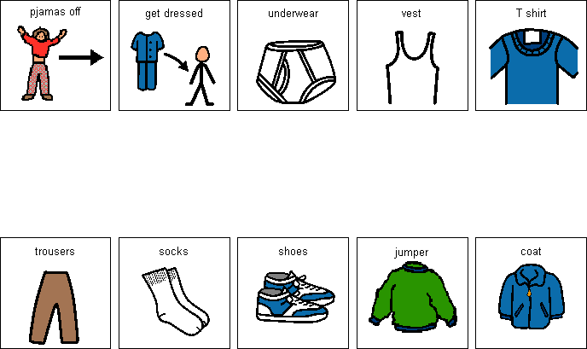
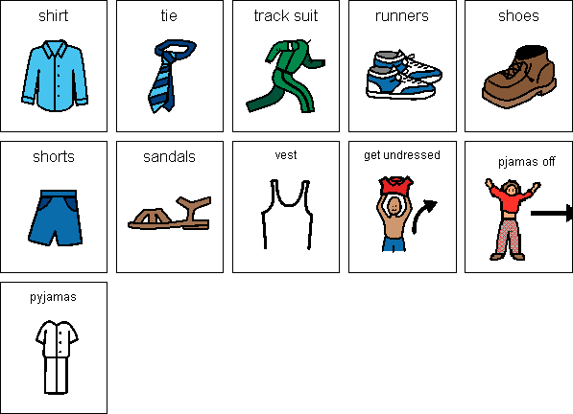
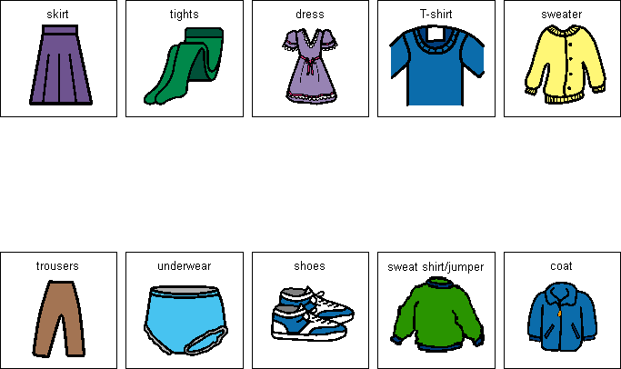

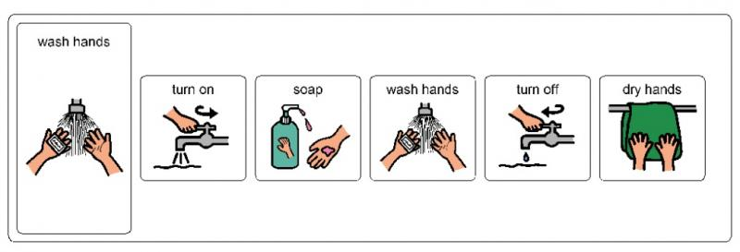

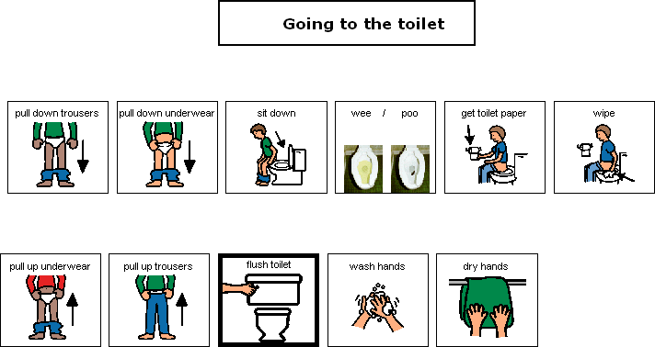

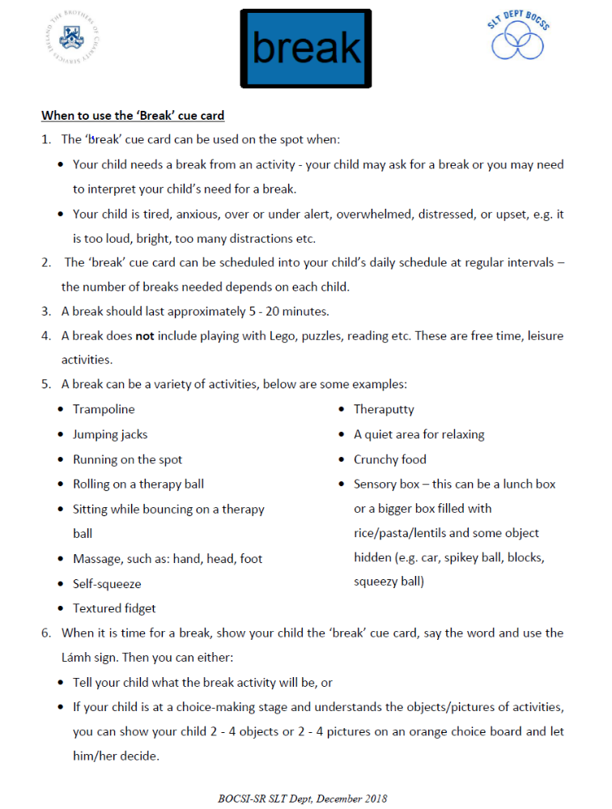
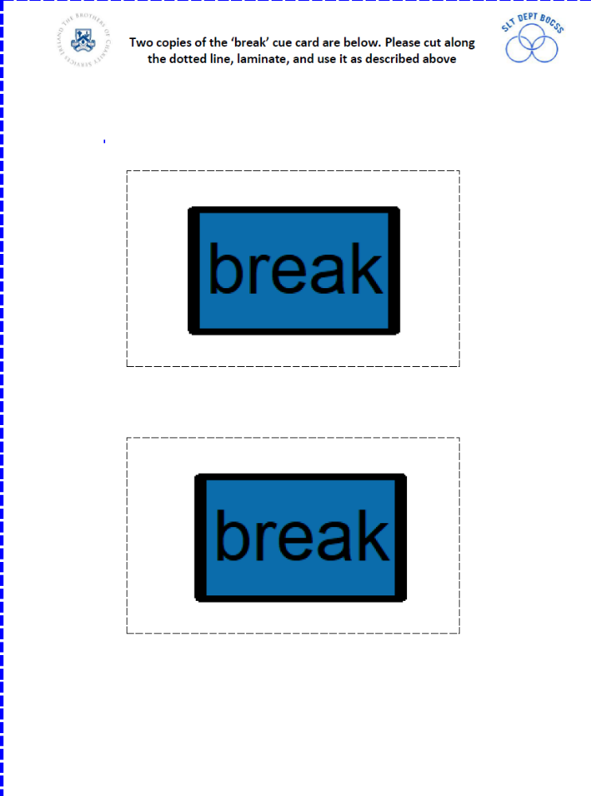
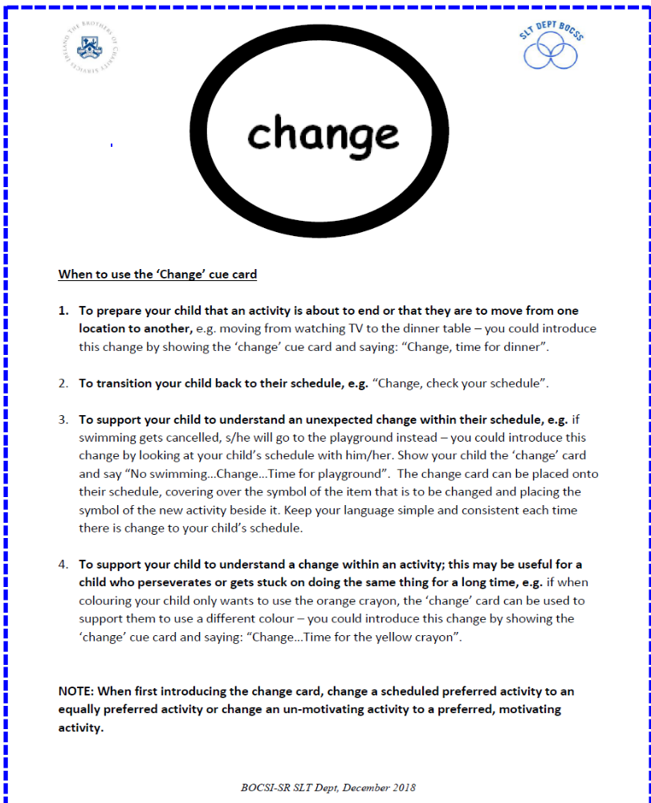
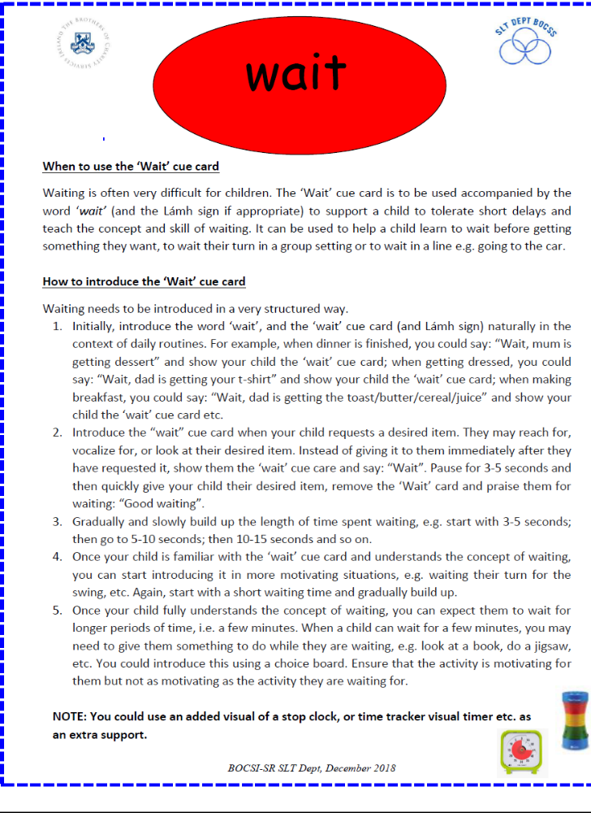
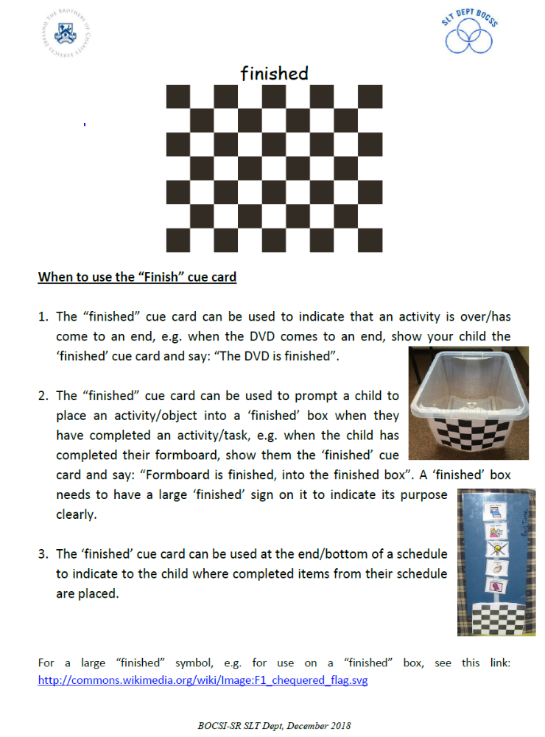
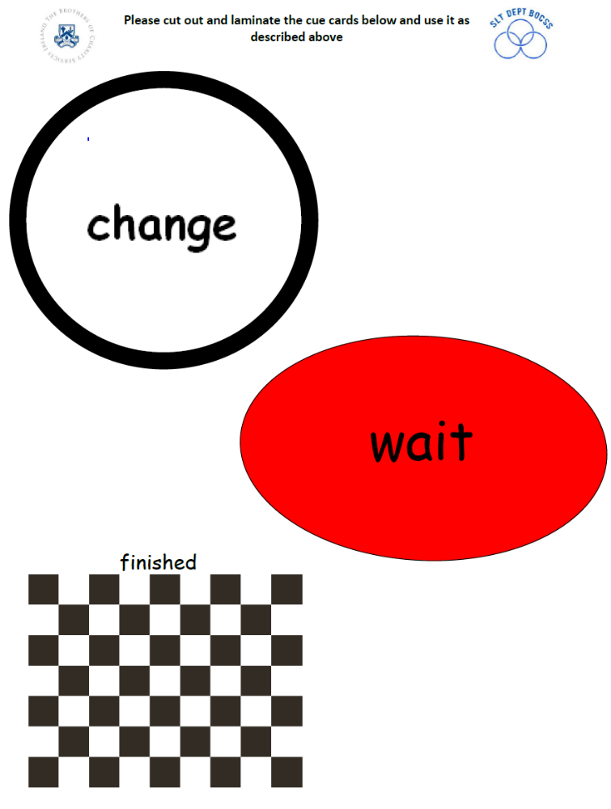
Calendars

Calendars can be used to prepare for any upcoming events, changes or transitions. When you find out a start date you and your child can mark the date school is starting on the calendar. Depending on what you think your child will understand best you can use with a word, a drawing, a picture symbol or a photo of your child’s school. See examples below where August 31st is used as a start date.
Throughout the month with your child, cross off each date and count how many days until they are back to school. For example on the 15th of August you might say ‘9 days until you are back to school’. It may also be useful to show them a photo of their school on your phone.
If your child asks a lot of questions about going back to school you might look at the calendar more than once a day. When they are used to the calendar they may be able to check when they are going back to school independently.

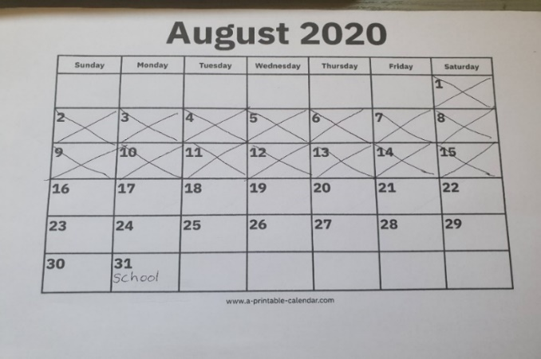
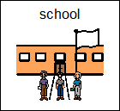

Top tip: You can find calendar templates on www.print-a-calendar.com. You can also find a guide to using calendars in our online ‘Using Visuals Supports’ presentations.

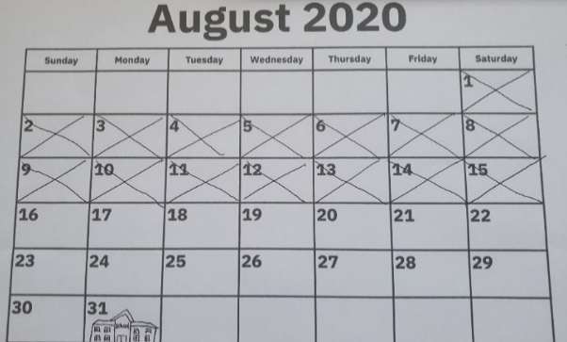

Top Tip: If you want to use this symbol to mark the calendar cut this square out.
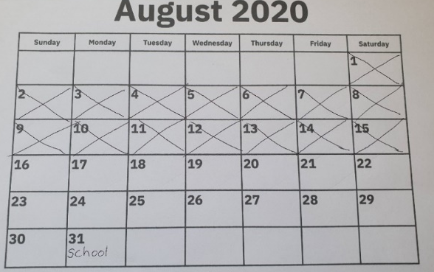

Taking Turns

Sometimes, children want to play with the same toy

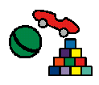

They may need to take turns with the toy. A "turn" is a chance for that person to play with the toy.
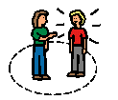
Sometimes it is my turn to play with the toys. Sometimes it is another child's turn to play with the toys. When the other child is playing with the toys, I must "wait" until it is my turn.
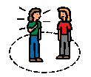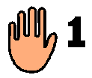

I will try to take turns playing with toys. I will try to let the other child have a turn to play.

Mum and dad will be happy if I take turns. 

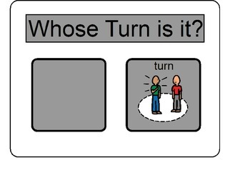
Add a photo of the child in the box

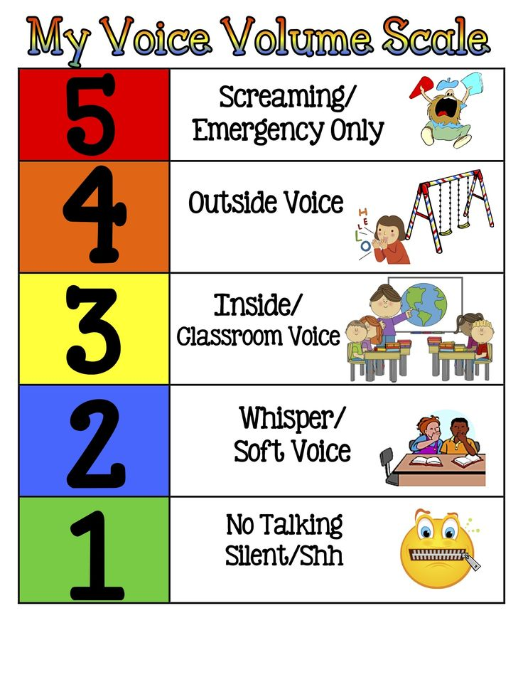
Playing Chase.

- When I want to play chase I ask "Do you want to play chase". | 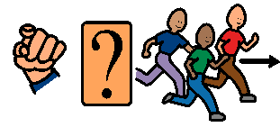
- One person is on.  They try and catch someone. | 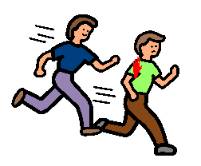
- The other children run as fast as they can.

- When I am on I run after my friends.
I touch them and say “caught you”

Then it is their turn to be on. They try and catch me.

- Playing chase is lots of fun! | 
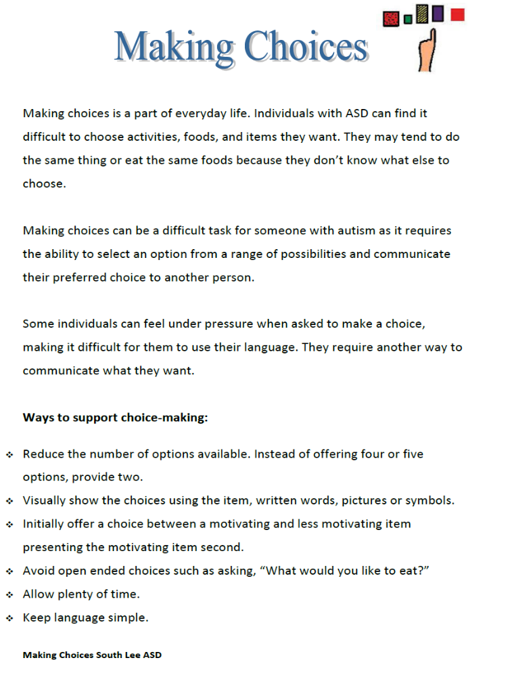

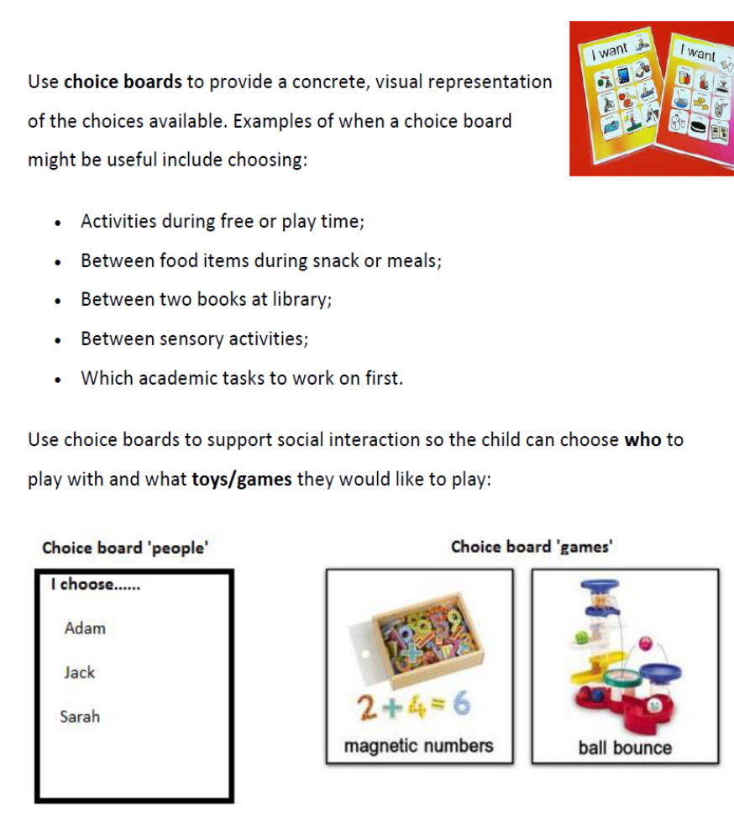
Using Fidgets

In school I sometimes find it hard to listen to my teacher. This is ok. 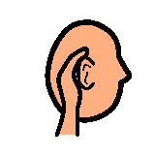

I can use a fidget to help me to listen.

I can use a paper clip , some blue tac or a small toy  as a fidget.

When I am listening to my teacher I can
- Hold my fidget in my hands 
- Move it
- Play with it

I may find it easier to listen to my teacher when I have a fidget. I will try and keep my fidget in my hands or under the desk.

When I am finished with my fidget I can put it in a special place.

My teacher will be happy when I use a fidget to help me to listen. 

